SMS-CB (Cell Broadcast)

🧾 What Is SMS-CB (Cell Broadcast)?
# Source: Chatgpt (GPT-5-Mini) at [1/21/2026]
SMS-CB stands for Short Message Service – Cell Broadcast.
It is a messaging service that allows mobile network operators to send text messages to all mobile devices in a specific geographic area, at the same time — without needing the recipients' phone numbers.
📢 Think of SMS-CB as a mass broadcast system, like a radio transmission, but for SMS.

📡 Key Features of SMS-CB:
# Source: Chatgpt (GPT-5-Mini) at [1/21/2026]
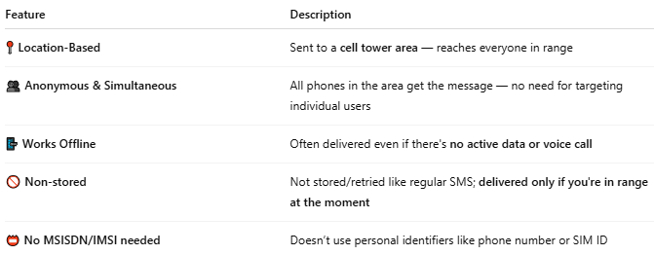

Feature | Description
📍 Location-Based | Sent to a cell tower area — reaches everyone in range
👥 Anonymous & Simultaneous | All phones in the area get the message — no need for targeting individual users
📴 Works Offline | Often delivered even if there's no active data or voice call
🚫 Non-stored | Not stored/retried like regular SMS; delivered only if you're in range at the moment
📛 No MSISDN/IMSI needed | Doesn’t use personal identifiers like phone number or SIM ID

🧠 Common Use Cases:
# Source: Chatgpt (GPT-5-Mini) at [1/21/2026]
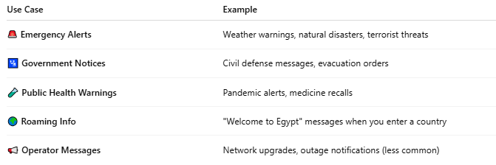

Use Case | Example
🚨 Emergency Alerts | Weather warnings, natural disasters, terrorist threats
🛂 Government Notices | Civil defense messages, evacuation orders
🧪 Public Health Warnings | Pandemic alerts, medicine recalls
🌍 Roaming Info | "Welcome to Egypt" messages when you enter a country
📢 Operator Messages | Network upgrades, outage notifications (less common)

🛠️ How SMS-CB Works (Simplified):
# Source: Chatgpt (GPT-5-Mini) at [1/21/2026]
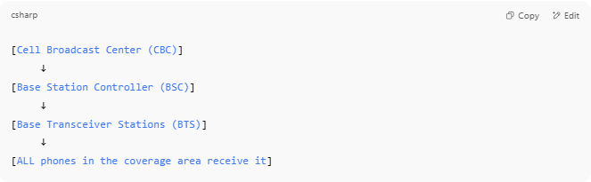

[Cell Broadcast Center (CBC)]
↓
[Base Station Controller (BSC)]
↓
[Base Transceiver Stations (BTS)]
↓
[ALL phones in the coverage area receive it]

- 📡 The Cell Broadcast Center (CBC) generates the message.
- It’s sent via BTS (cell towers) to all devices in range.
- Devices listen to broadcast channels, not personal numbers.

🆚 SMS-CB vs Regular SMS:
# Source: Chatgpt (GPT-5-Mini) at [1/21/2026]
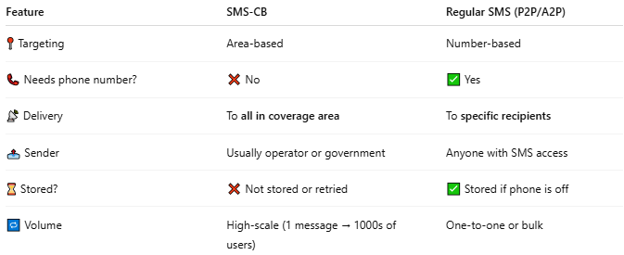

Feature | SMS-CB | Regular SMS (P2P/A2P)
📍 Targeting | Area-based | Number-based
📞 Needs phone number? | ❌ No | ✅ Yes
📡 Delivery | To all in coverage area | To specific recipients
📤 Sender | Usually operator or government | Anyone with SMS access
⌛ Stored? | ❌ Not stored or retried | ✅ Stored if phone is off
🔁 Volume | High-scale (1 message → 1000s of users) | One-to-one or bulk

🔐 Security and Standards:
# Source: Chatgpt (GPT-5-Mini) at [1/21/2026]
- Works over GSM, 3G, 4G, 5G
- Defined in 3GPP, ETSI, and ITU standards
- Supports multi-language and multi-channel delivery
- Integrated with national alert systems (like EU-Alert, CMAS, Earthquake Alerts, etc.)

📖 Summary:
# Source: Chatgpt (GPT-5-Mini) at [1/21/2026]
SMS-CB (Cell Broadcast) is:
- 📢 A one-to-many messaging service for mobile users in a location
- 📍 Useful for emergencies, alerts, and mass announcements
- ✅ Doesn’t require phone numbers or data access
- 💡 Sent through cell towers, not individual messaging paths

